Pair Programming 6 Turn In

Name: _____Matthew Krahel _________ Username: _______C1010B11_________

Partner name: _______Blake Hodges___________ Partner username: ____C1010B06________

_X_ I certify that my partner did work with me on these pair programming activities.

**Blake and I work together well and share the work well.**

SCORE: ____________ (to be filled in by instructor)

6a (4 points)

**/* File: pp6a.cpp**

**\* Author: Blake Hodges and Matthew Krahel.**

**\* This program reads one number from an input file and writes it to an output file**

**\*/**

**#include <iostream>**

**#include <fstream>**

**#include <cstdlib>**

**#include <iomanip>**

**using namespace std;**

**//declare functions**

**void inputFunction(ifstream& input, double& num);**

**//precondition: an input file and reference variables**

**//postcondition: reference variable is updated with next**

**//number from the input file.**

**void outputFunction(ofstream& output, double num);**

**//precondition: an output file and a variable to be put in**

**//the output file.**

**//postcondition: The output file receives the number as a part**

**//of the sentence: The number is**

**int main()**

**{**

**double num;**

**ifstream input; // declare file variables**

**ofstream output;**

**char fileName[256];// input filename**

**char outFile[256];// output filename**

**//ask user for filename of input file**

**cout << "Enter input Filename (Please no spaces): \n";**

**cin >> fileName;**

**// open input file, read from it, close it**

**input.open(fileName);**

**//check for existence of input file**

**if(input.fail()) {**

**cout << "FileName " << fileName << " is not found.\n";**

**exit(1);**

**}**

**else{**

**cout << "Enter output file name: ";**

**cin >> outFile;**

**}**

**// Check if input file is empty**

**char c;**

**input.get(c);**

**if(input.eof()){**

**cout << "File " << fileName << " is empty\n";**

**}**

**else {**

**input.putback(c);**

**}**

**// open output file, write to it, close it**

**output.open(outFile);**

**while(!input.eof()){**

**inputFunction(input, num);**

**outputFunction(output, num);**

**}**

**// close the input file**

**input.close( );**

**output.close( );**

**return 0;**

**}**

**//functions**

**void inputFunction(ifstream& input, double& num)**

**//precondition: an input file and reference variables**

**//postcondition: reference variable is updated with next**

**//number from the input file.**

**{**

**input >> num;**

**}**

**void outputFunction(ofstream& output, double num)**

**//precondition: an output file and a variable to be put in**

**//the output file.**

**//postcondition: The output file receives the number as a part**

**//of the sentence: The number is**

**{**

**output.setf(ios::fixed);**

**output.setf(ios::showpoint);**

**output.precision(2);**

**output << "The number is $" << num << endl;**

**}**

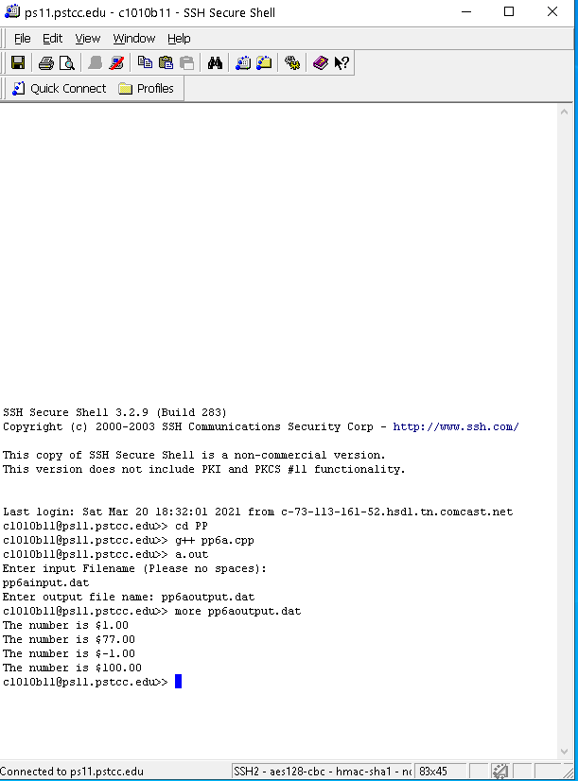

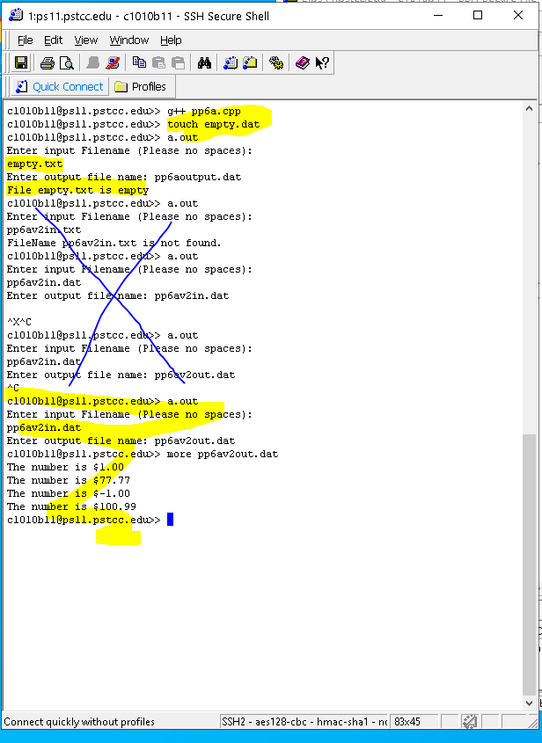

6b (2 points)

**/* File: pp6b.cpp**

**\* Author: Blake Hodges and Matthew Krahel.**

**\* This program reads numbers from an input file and outputs**

**\* in a specific and neat format.**

**\*/**

**#include <iostream>**

**#include <fstream>**

**#include <cstdlib>**

**#include <iomanip>**

**using namespace std;**

**int main()**

**{**

**ifstream input; // declare file variables**

**char fileName[256] = "pp6b.dat";// input filename**

**string accountNum;**

**double balance;**

**// open input file**

**input.open(fileName);**

**//check for existence of input file**

**if(input.fail()) {**

**cout << "FileName " << fileName << " is not found.\n";**

**exit(1);**

**}**

**//Output header**

**cout << setw(14) << left << "Account Number";**

**cout << " ";**

**cout << setw(8) << right << "Balance\n";**

**cout << "-------------------------\n";**

**//Output account numbers and balances**

**while(!input.eof())**

**{**

**input >> accountNum;**

**cout << setw(14) << left << accountNum; //Output Account Number**

**cout << " $ ";**

**//To display display 2 decimals**

**cout.setf(ios::fixed);**

**cout.setf(ios::showpoint);**

**cout.precision(2);**

**input >> balance;**

**cout << setw(8) << right << balance << "\n"; //Output Balance**

**}**

**input.close( );**

**return 0;**

**}**

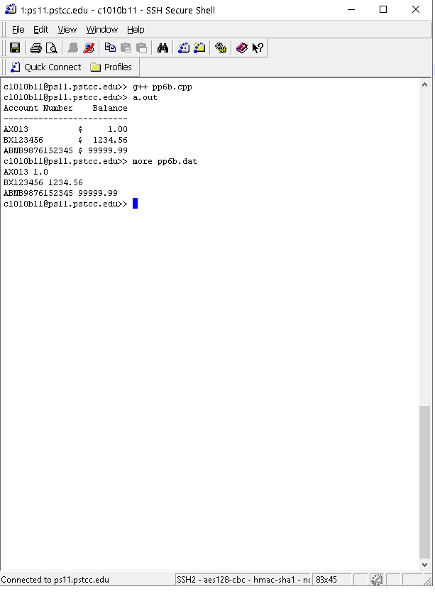

6c (2 points)

**/* File: pp6c.cpp**

**\* Author: Blake Hodges and Matthew Krahel.**

**\* This program prompts the user for a word twice and reads only the first**

**\*word typed in entry**

**\*/**

**//Declare Libraries and namespaces used**

**#include <iostream>**

**#include <string>**

**using namespace std;**

**//readline function declaration**

**//Precondition: function has a self defined char variable that is used**

**//in the function body.**

**//Post Condititon: function performs the get function again the cin object to**

**//check for first empty space or new line**

**void readline();**

**//Begin main function**

**int main() {**

**//Declare string variables**

**string word1;**

**string word2;**

**//Prompt user for entry**

**cout << "Please enter a word \n";**

**cin >> word1;**

**//Function call for readline function.**

**readline();**

**//Prompt user for second word.**

**cout << "Please enter another word \n";**

**cin >> word2;**

**//Function call for readline function**

**readline();**

**//print first word and second word after readline functions**

**cout << word1 << " " << word2 <<endl;**

**//return success to OS**

**return 0;**

**}**

**//readline function**

**//Precondition: function has a self defined char variable that is used**

**//in the function body.**

**//Post Condititon: function performs the get function again the cin object to**

**//check for first empty space or new line**

**void readline(){**

**char character;**

**do{**

**cin.get(character);**

**}while (character != '\n');**

**}**

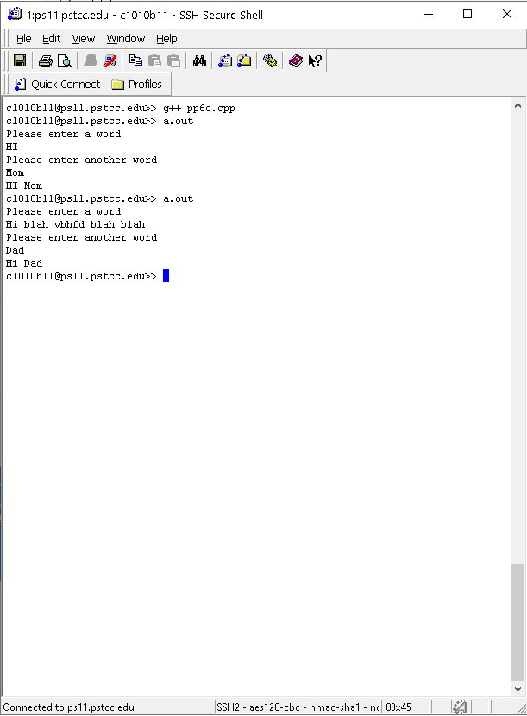

6d (2 points)

**/* File: pp6d.cpp**

**\* Author: Blake Hodges and Matthew Krahel.**

**\* This program requests an input from the user and**

**\* outputs information on that input.**

**\*/**

**//Declare Libraries and namespaces used**

**#include <iostream>**

**#include <cctype>**

**using namespace std;**

**int main()**

**{**

**//Declare Variables**

**char var1;**

**//Request Character from user**

**cout << "Enter One Character: ";**

**cin.get(var1);**

**//Determine aspects of the character**

**if(isupper(var1)){**

**cout << "is uppercase" << endl;**

**}**

**if(islower(var1)){**

**cout << "is lowercase" << endl;**

**}**

**if(isalpha(var1)){**

**cout << "is alphabetic" << endl;**

**}**

**if(isdigit(var1)){**

**cout << "is a digit" << endl;**

**}**

**if(isspace(var1)){**

**cout << "is white space" << endl;**

**}**

**return 0;**

**}**

